ALGO Trading

GARCH is one of the most advanced volatility models used even by hedge funds. You’re not predicting direction, just future movement intensity (volatility).
Markets move in clusters —sometimes calm (tiny moves), sometimes wild (big swings). GARCH’s only job is to measure how wild the market is right now — and predict how wild the next candle might be.
Then your algo uses that forecast to decide position size:
- If market is calm → volatility low → trade bigger.
- If market is jumpy → volatility high → trade smaller.
Capital = 100000/-
Case | Market Condition | Forecast Volatility | Meaning in ₹ | Risk per Trade | Per-Share Movement (Volatility × Price) | Formula → ₹500 / (Vol × Price) | Position Size (Shares) | Logic
Base Case | Normal market | 1% | Moderate | ₹500 | ₹1000 × 0.01 = ₹10 | ₹500 / ₹10 | 50 shares | Standard volatility → medium position
High Volatility | Market is wild | 2% | Double movement | ₹500 | ₹1000 × 0.02 = ₹20 | ₹500 / ₹20 | 25 shares | Market moving fast → reduce exposure
Low Volatility | Market calm | 0.5% | Small moves | ₹500 | ₹1000 × 0.005 = ₹5 | ₹500 / ₹5 | 100 shares | Market steady → increase size
Very Calm | Flat phase | 0.25% | Tiny moves | ₹500 | ₹1000 × 0.0025 = ₹2.5 | ₹500 / ₹2.5 | 200 shares | Very low noise → large position
Very Volatile | Turbulent phase | 4% | Huge swings | ₹500 | ₹1000 × 0.04 = ₹40 | ₹500 / ₹40 | 12 shares | Extreme volatility → protect capital

Step-by-step for the Base Case (vol = 1%)
1️⃣ Capital = ₹100,000
2️⃣ Risk per trade = 0.5% × ₹100,000 = ₹500
3️⃣ Forecast volatility = 1% (from GARCH)
4️⃣ Price per share = ₹1000
5️⃣ Per-share fluctuation = ₹1000 × 1% = ₹10
6️⃣ Shares = ₹500 ÷ ₹10 = 50 shares
✅ So your algo buys 50 shares — it’s risking ₹500 if price moves roughly 1% against it.

Formula for GARCH

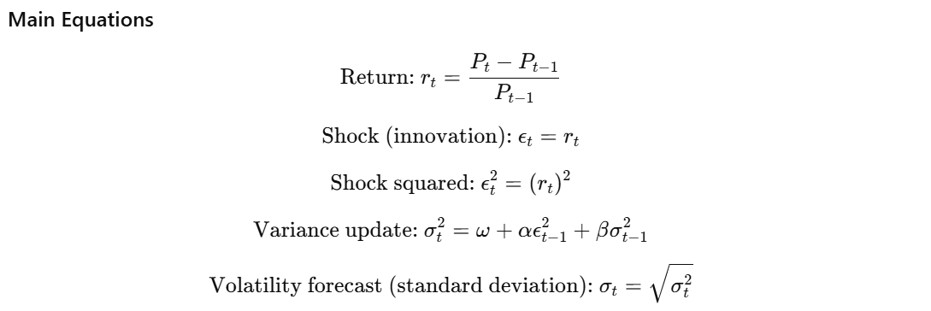

Symbol | Name | Meaning / Intuition | Typical Range
Pₜ | Price at time t | Latest market price (e.g., closing price of a candle or tick) | ₹1000, ₹1010, etc.
rₜ | Simple return | The % price change from previous period: ( (Pₜ - Pₜ₋₁) / Pₜ₋₁ ) | +0.01 (1%) or -0.005 (-0.5%)
εₜ | Shock (innovation) | The “surprise” or deviation in return — how far it moved unexpectedly | Usually same as rₜ if mean ≈ 0
εₜ² | Squared shock | The magnitude of volatility in that period; large ε² = strong move | Always positive (e.g., 0.0001 = 1%²)
σₜ² | Variance | The predicted volatility level for time t (average squared deviation) | 0.00009 ≈ (0.95%)²
σₜ | Standard deviation (volatility forecast) | The per-candle or per-period volatility forecast by the model | 0.0095 → 0.95%
ω (omega) | Constant term | Long-run base variance (the volatility floor even if market is calm) | 0.000001 (≈ 0.1%²)
α (alpha) | Reaction coefficient | Sensitivity to recent shocks — how much weight is given to yesterday’s surprise | Typically 0.05 – 0.15
β (beta) | Persistence coefficient | Memory of past volatility — how slow or fast volatility decays over time | Typically 0.80 – 0.90

How GARCH Forecast Volatility ?

t | Price (Pₜ) | Return (rₜ = εₜ) | εₜ² = (rₜ)²
0 | 1000 | — | —
1 | 1010 | 0.01000000 | 0.00010000
2 | 1005 | -0.004950495 | 0.000024505
3 | 1020 | 0.014925373 | 0.000222770
4 | 1015 | -0.004901961 | 0.000024039
5 | 1030 | 0.014778325 | 0.000218450

step t | εₜ₋₁² (used) | σₜ² = ω + α·εₜ₋₁² + β·σₜ₋₁² | σₜ = √σₜ² (per-candle std)
1 | ε₀² = 0.0001000000 | 0.000001 + 0.1·0.000100 + 0.85·0.000100 = 0.0000960000 | 0.009798 (0.9798%)
2 | ε₁² ≈ 0.000024505 | 0.000001 + 0.1·0.000024505 + 0.85·0.000096000 = 0.0000850505 | 0.009220 (0.9220%)
3 | ε₂² ≈ 0.000222770 | 0.000001 + 0.1·0.00022277 + 0.85·0.0000850505 = 0.0000955700 | 0.009777 (0.9777%)
4 | ε₃² ≈ 0.000024039 | 0.000001 + 0.1·0.000024039 + 0.85·0.00009557 = 0.0000846383 | 0.009200 (0.9200%)
5 | ε₄² ≈ 0.000218450 | 0.000001 + 0.1·0.00021845 + 0.85·0.0000846383 = 0.0000947876 | 0.009737 (0.9737%)

One-step ahead forecast (t=6)
